srsRAN and Its Advantages
- open source under AGPLv3, portable across processor architectures including x86/ARM and with minimal third-party dependencies.
- PC (at least dual-core i5, better quad-core i7) with USB 3.0 to attach the USRP B200/B210 to run srsRAN.
- srsRAN Enterprise 5G is fully portable across x86, ARM and AMD processors with SIMD optimizations.
https://www.srslte.com/srsran-project-update
https://open5gs.org/open5gs/docs/tutorial/01-your-first-lte/
https://srs.io/srsran-enterprise-5g/
alignment with 3GPP standards:
- largely compliant with 3GPP standards for foundational 4G/5G functionality
- But, it prioritizes practical, open-source deployment over full 3GPP feature completeness. Advanced features (e.g., network slicing, Xn enhancements) are either experimental or roadmap items.
- Validate against 3GPP Technical Specifications (e.g., TS 38.3xx for NR, TS 36.3xx for LTE).
- Test with commercial UEs and cores (e.g., Open5GS) to confirm interoperability.

NR Protocol Stack
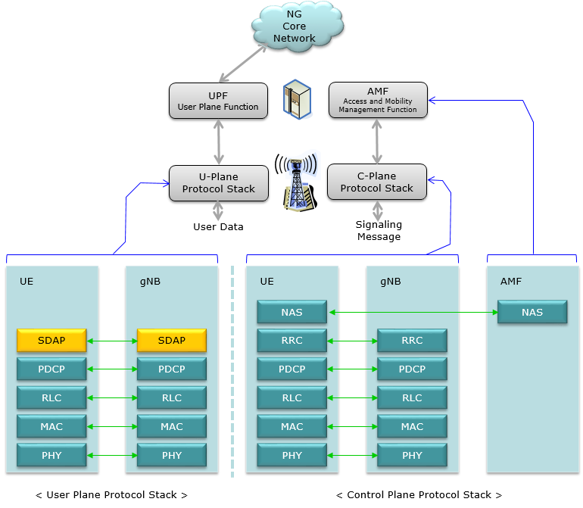
User Plane Layers
- PHY: Handles radio signals with features like beamforming, flexible numerology (15kHz–240kHz), and massive MIMO.
- MAC: Schedules and multiplexes traffic, uses HARQ, and manages beam-based communication.
- RLC: Provides segmentation, reassembly, error correction (ARQ), and in-sequence delivery.
- PDCP: Handles header compression, ciphering, integrity protection, and delivery ordering.
- SDAP: 5G-exclusive layer mapping QoS flows to DRBs, enabling service differentiation.
Control Plane Layers
- RRC: Manages connection setup, mobility, handovers, and broadcast info.
- PDCP, RLC, MAC, PHY: Same as user plane, for control signaling.
- NAS: Interacts with the 5G core (AMF) for mobility management, authentication, and session control.
5G | ShareTechnote
Physical Resource Blocks (PRBs) for Allocation
Physical resource blocks (PRBs) are the smallest units of resource allocation in 5G New Radio (NR). example, with 15 kHz subcarrier spacing, one PRB spans 180 kHz.
PRBs span one slot, typically 14 symbols for normal cyclic prefix in Time Domain
- Resource Utilization Metrics: KPIs may include the percentage of PRBs in use, the distribution of PRBs among users, and resource block utilization efficiency.
- Throughput and Data Rate: Measuring the throughput per PRB or overall data rate can be essential to gauge the system performance.
- Scheduling Efficiency: KPIs may help assess the performance of scheduling algorithms in how they allocate PRBs to different users, aiming to maximize throughput while meeting QoS requirements.
Explanation of Config Files
- ue.conf: Configures UE parameters, including cell ID, bandwidth, and frequency. This file is essential for defining how the UE connects to the network.
- gnb.conf: Sets gNB parameters, including RF settings, E2 interface configurations, and cell parameters. This file ensures proper communication between the gNB and the core network.
srsRAN_4G/srsue/ue.conf.example at master · srsran/srsRAN_4G

NoSQL DB Be Involved
Integrate srsRAN with Open5GS (5G Core):
Open5GS uses MongoDB (a NoSQL DB) to store user profiles (subscriber data, authentication keys, session state).
Use it in Cloud-Native Environments:
If you're scaling RAN components across Kubernetes, you might use NoSQL DBs (like Redis or etcd) for custom orchestration or session management
srsRAN gNB on Kubernetes — srsRAN Project documentation

